[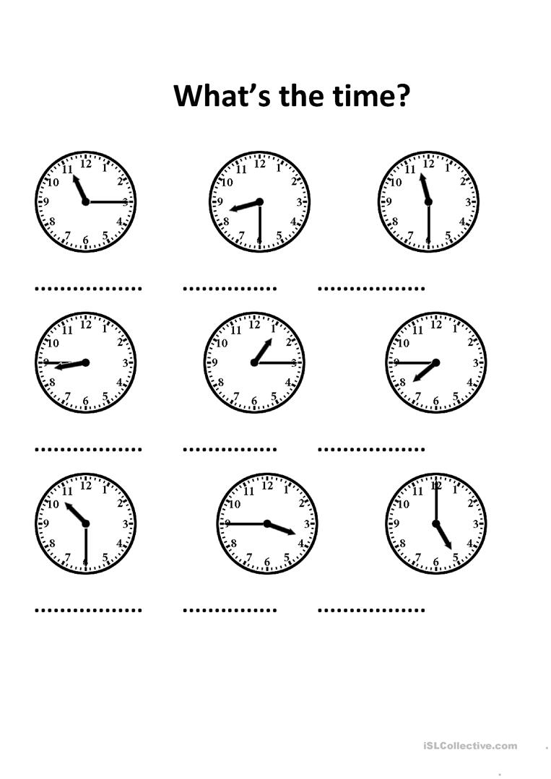](https://www.google.com/url?sa=i&url=https%3A%2F%2Fen.islcollective.com%2Fenglish-esl-worksheets%2Fvocabulary%2Ftime%2Fwhats-time%2F108129&psig=AOvVaw0_XU_2_VLXYARvt96MlaxO&ust=1585752144598000&source=images&cd=vfe&ved=0CAIQjRxqFwoTCOianp35xOgCFQAAAAAdAAAAABAU)