Score | Mark | Teacher’s Signature | Parents’ Signature
Basic Competency: Understanding simple descriptive passage

Part 1. Read the text and complete the sentence by circle the correct answer (Score : 5)
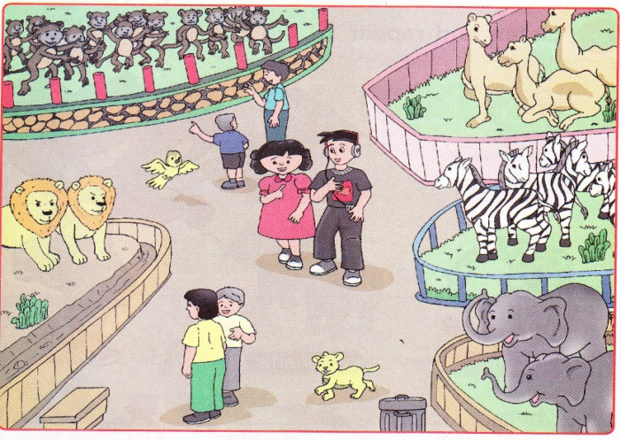
In the Zoo
In the zoo, there are zebras, elephants, monkey, crocodiles, giraffes, snakes, lions, tigers, and many more. Look, there are two elephants, five zebras, and three camels on the right. There are two lions and twelve monkeys on the left. There is a bird. There is a cat also.

(Source :Grow With English Book 1, Dr. Mukarto, M.Sc, Erlangga)

- .................. two elephants in the zoo  - There is  - There are  - There are ........... zebras in the zoo  - Five  - Two  - ................. a cat in the zoo  - There is  - There are | - There are ............... camels in the zoo  - Five  - Three  - There are ................ monkey in the zoo  - Eleven  - Twelve

Part 2. Look at the picture and put a thick (√ ) to the most appropriate adjective (score : 6)
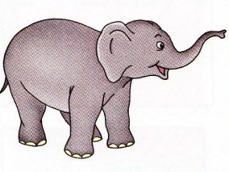
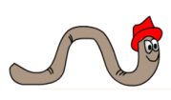
- big 4. long
small short

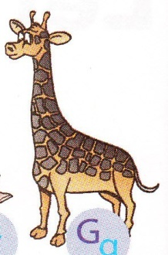

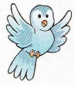
- big 5. tall
small short

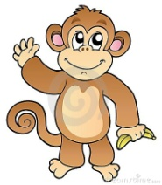
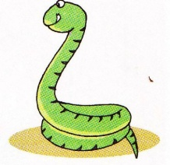
- long 6. tall
short short

Keynotes
- .................. two elephants in the zoo
- There is
- There are

- There are ........... zebras in the zoo
- Five
- Two

- ................. a cat in the zoo
- There is
- There are

- There are ............... camels in the zoo
- Five
- Three

- There are ................ monkey in the zoo
- Eleven
- Twelve

Part 2. Look at the picture and put a thick (√ ) to the most appropriate adjective.
- big 4. long
√
small short
√

- big 5. tall
√

small short
√

- long 6. tall
√

short short
√

